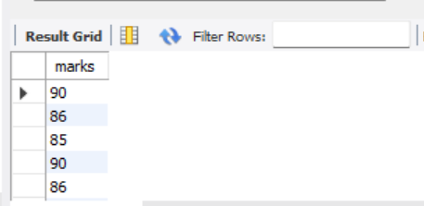 select marks from STUDENT_INFO where marks between 85 and 90;

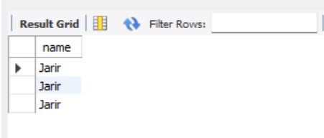 select name from STUDENT_INFO where name='Jarir' group by roll;

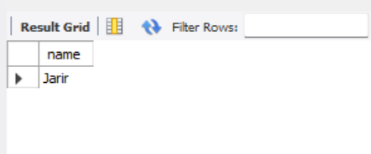select name from STUDENT_INFO where name='Jarir' group by roll having roll=03;

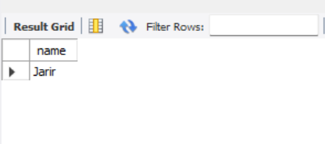 select name from STUDENT_INFO where name='Jarir' group by roll having roll=03 order by roll;

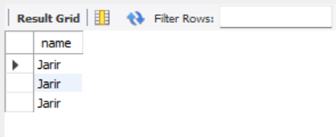 select name from STUDENT_INFO where name='Jarir' group by roll having name='Jarir' or roll=03 order by roll;

-- Create Database

create DATABASE ICE;

USE ICE;

-- Create Table

create table table1(

name varchar(50),

roll int(30)

);

-- Insert Value

INSERT INTO table1 (name,roll) VALUES('Shifa',1);

INSERT INTO table1(name,roll) VALUES('Jadwa',2);

-- Show Data From Table

select * From table1;

-- Create Table

create table table2(

roll int(30),

CGPA float(20)

);

-- Insert Value

INSERT INTO table2(roll,CGPA) VALUES(1,3.95);

INSERT INTO table2(roll,CGPA) VALUES(2,3.75);

select * from table2;

select table1.name,table1.roll,table2.CGPA from table1 join table2 on table1.roll=table2.roll;

table1: table2:

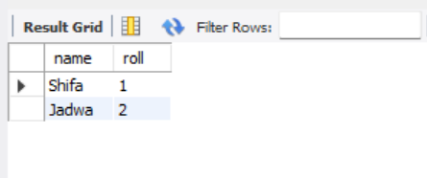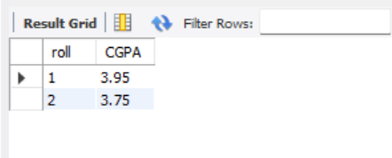

Join/natural join:

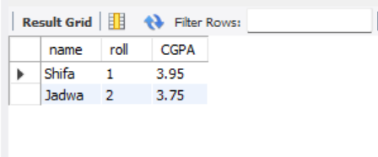 select table1.name,table1.roll,table2.CGPA from table1 join table2 on table1.roll=table2.roll;

Cartesian join:

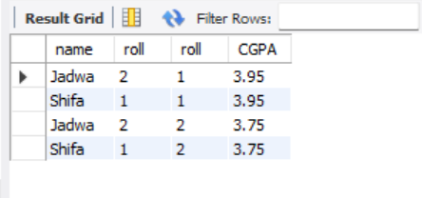

select table1.name,table1.roll,table2.roll,table2.CGPA from table1 cross join table2;

Table1: table2:

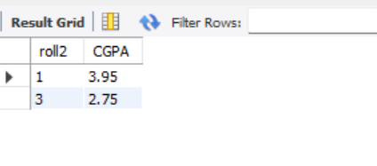

Left outer join:

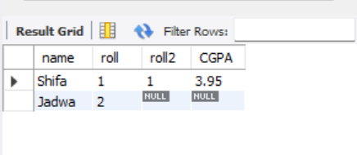

select table1.name,table1.roll,table3.roll2,table3.CGPA from table1 left join table3 on table1.roll=table3.roll2;

right outer join:

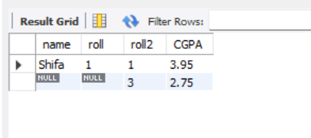

select table1.name,table1.roll,table3.roll2,table3.CGPA from table1 right join table3 on table1.roll=table3.roll2;

full outer outer:

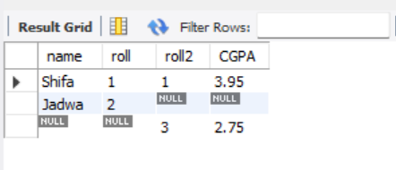

select table1.name,table1.roll,table3.roll2,table3.CGPA from table1 left join table3 on table1.roll=table3.roll2

union

select table1.name,table1.roll,table3.roll2,table3.CGPA from table1 right join table3 on table1.roll=table3.roll2;

table4: group by first:

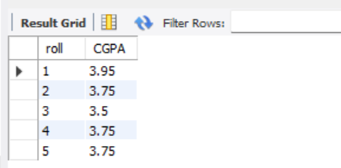 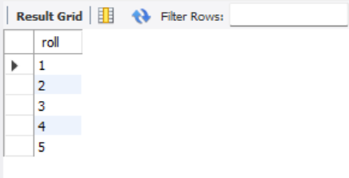

select roll from table4 where roll<=5 group by roll order by count(CGPA)asc;

group by 4th:

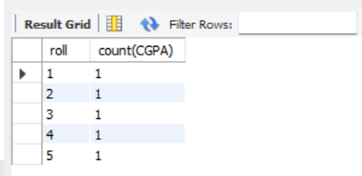

select roll,count(CGPA) from table4 group by roll order by count(CGPA)asc;

group by 2nd:

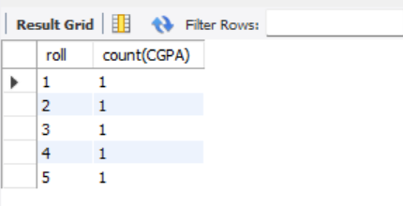

select roll,count(CGPA) from table4 group by roll;

group by 3rd:

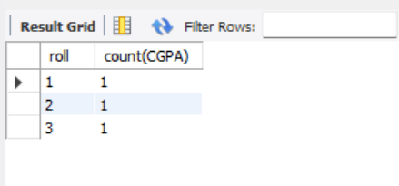

select roll,count(CGPA) from table4 where roll<4 group by roll;

group by 5th:

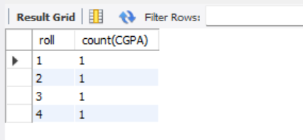

select roll,count(CGPA) from table4 where roll<=4 group by roll order by count(CGPA)asc;

group by 6th:

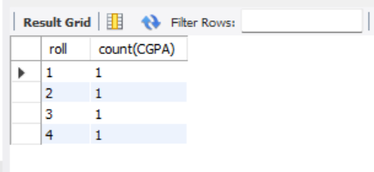

select roll,count(CGPA) from table4 where roll<=4 group by roll having count(CGPA)<=1 order by count(CGPA)asc;

between:

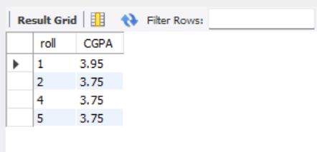

select * from table4 where CGPA between 3.67 and 4.00;

-- Create Database

create DATABASE ICE;

USE ICE;

-- Create Table

create table table1(

name varchar(50),

roll int(30)

);

-- Insert Value

INSERT INTO table1 (name,roll) VALUES('Shifa',1);

INSERT INTO table1(name,roll) VALUES('Jadwa',2);

-- Show Data From Table

select * From table1;

-- Create Table

create table table2(

roll int(30),

CGPA float(20)

);

-- Insert Value

INSERT INTO table2(roll,CGPA) VALUES(1,3.95);

INSERT INTO table2(roll,CGPA) VALUES(2,3.75);

select * from table2;

select table1.name,table1.roll,table2.CGPA from table1 join table2 on table1.roll=table2.roll;

select table1.name,table1.roll,table2.CGPA from table1 cross join table2 on table1.roll=table2.roll;

select table1.name,table1.roll,table2.roll,table2.CGPA from table1 cross join table2;

-- Create Table

create table table3(

roll2 int(30),

CGPA float(20)

);

-- Insert Value

INSERT INTO table3(roll2,CGPA) VALUES(1,3.95);

INSERT INTO table3(roll2,CGPA) VALUES(3,2.75);

select * from table3;

-- left outer join

select table1.name,table1.roll,table3.roll2,table3.CGPA from table1 left join table3 on table1.roll=table3.roll2;

-- right outer join

select table1.name,table1.roll,table3.roll2,table3.CGPA from table1 right join table3 on table1.roll=table3.roll2;

-- full outer join

select table1.name,table1.roll,table3.roll2,table3.CGPA from table1 left join table3 on table1.roll=table3.roll2

union

select table1.name,table1.roll,table3.roll2,table3.CGPA from table1 right join table3 on table1.roll=table3.roll2;

-- select table1.name,table1.roll,table3.roll2,table3.CGPA from table1 full join table3 on table1.roll=table3.roll2;

-- Create Table

create table table4(

roll int(30),

CGPA float(20)

);

-- Insert Value

INSERT INTO table4(roll,CGPA) VALUES(1,3.95);

INSERT INTO table4(roll,CGPA) VALUES(2,3.75);

INSERT INTO table4(roll,CGPA) VALUES(3,3.50);

INSERT INTO table4(roll,CGPA) VALUES(4,3.75);

INSERT INTO table4(roll,CGPA) VALUES(5,3.75);

-- show table

select * from table4;

-- group by

select roll from table4 where roll<=5 group by roll order by count(CGPA)asc;

select roll,count(CGPA) from table4 group by roll;

select roll,count(CGPA) from table4 where roll<4 group by roll;

select roll,count(CGPA) from table4 group by roll order by count(CGPA)asc;

select roll,count(CGPA) from table4 where roll<=4 group by roll order by count(CGPA)asc;

select roll,count(CGPA) from table4 where roll<=4 group by roll having count(CGPA)<=1 order by count(CGPA)asc;

-- between

select * from table4 where CGPA between 3.67 and 4.00;